Julian Burgoff

10/25/2022

Analysis of Environmental Data

Lab 5

1. exp_fun = function(x, a, b)

{

return(a *exp(-b * x))

}

1. A picture containing chart

   Description automatically generated
2. Parameter a is the height of the curve at the start.
3. Parameter b is the rate of decay. The higher the number, the steeper the initial slope of the curve.
4. Chart

   Description automatically generated with medium confidence
5. Parameter a changes the initial slope of the curve where higher values cause steeper slope.
6. Parameter b dictates the height of the peak of the curve, where smaller b values cause the curve to peak at higher y values given the same value for parameter a.
7. curve(line_point_slope(x, 750, 0.3, -0.0005), add = TRUE)

I chose a negative slope and tried to use a point value that split the points of the plot fairly evenly.

1. 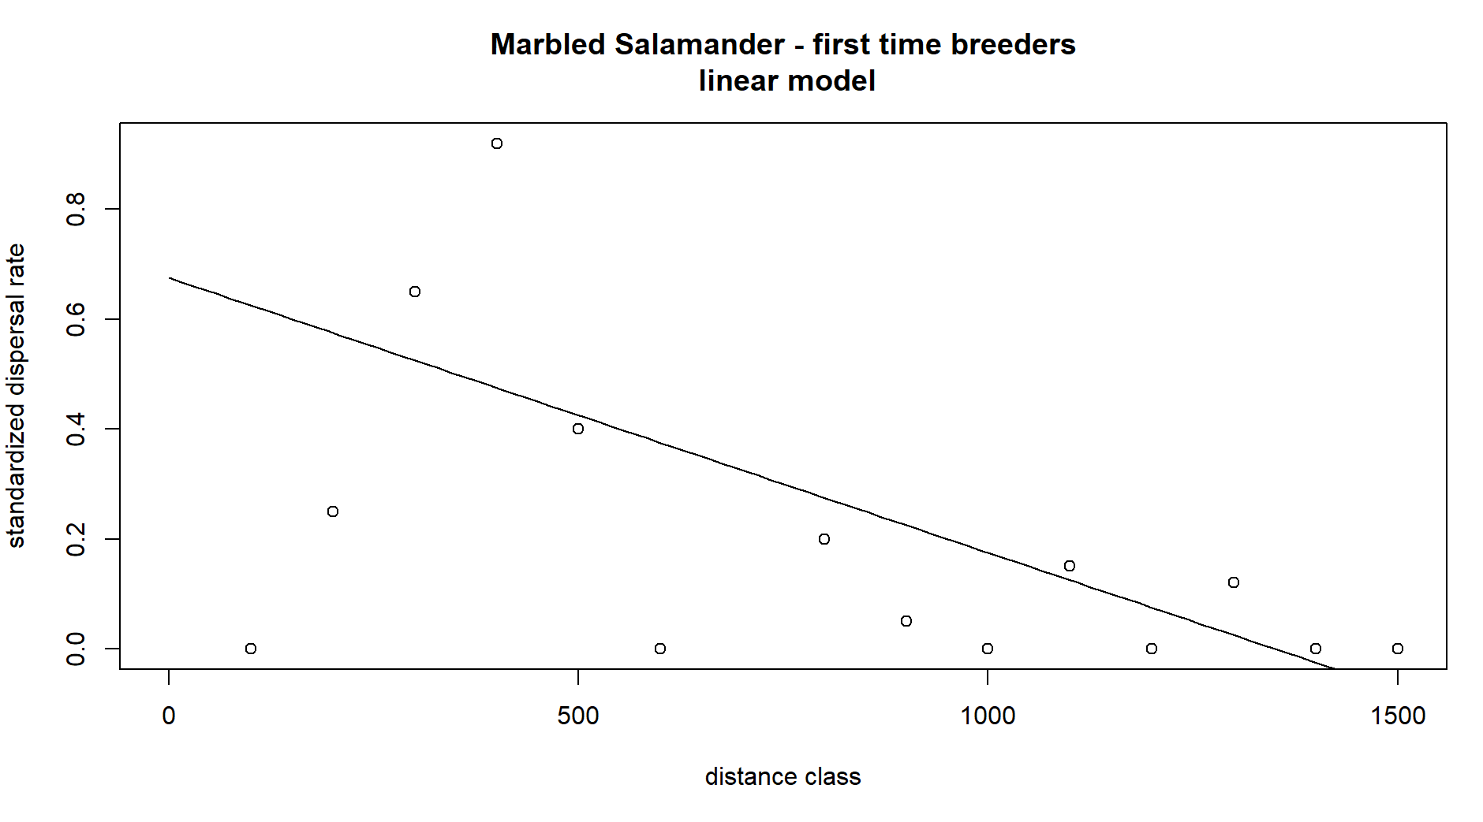
2. curve(exp_fun(x, 2, 1/200), add = TRUE, from = 0, to = 1500, ann = FALSE, axes = TRUE, ylab = "f(x)"); box()

I chose 2 and 1/200 just by trial and error to try and get the curve to split the data points as best as possible.

1. Chart

   Description automatically generated with low confidence
2. curve(ricker_fun(x, 1/210, 1/275), from = 0, to = 1500,

add = TRUE, ylab = "f(x)", xlab = "x")

I chose 1/210 and 1/275 by trial and error

1. 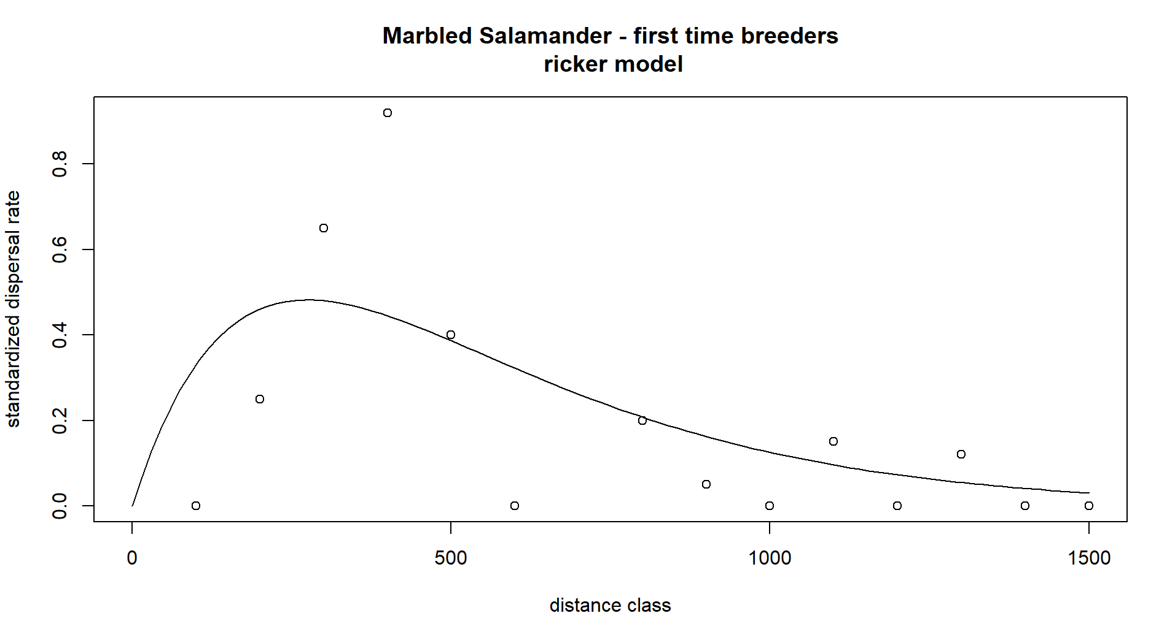
2. observed= dispersal$disp.rate.ftb

ricker_predicted= ricker_fun(dispersal$dist.class, 1/210, 1/275)

resids_ricker= c(observed - ricker_predicted)

exp_predicted= exp_fun(dispersal$dist.class, 1/200, 1/200)

resids_exp= c(observed- exp_predicted)

linear_predicted= line_point_slope(dispersal$dist.class, 750, 0.3, -0.0005)

resids_linear= c(observed - linear_predicted)

dat_resids= data.frame(dispersal$disp.rate.ftb,resids_linear, resids_exp, resids_ricker)

1. Chart, histogram

   Description automatically generated